Executive Comparison: Classical Forecasting versus XGBoost Forecasting for Texas HealthLink
To: Board of Directors, Texas HealthLink
From: Barakat Adigun, Blessing Anoroh, Denise Atherley, Brandon Chanderban; Data Scientists
Subject: Executive Comparison of Classical and Machine Learning Forecasting Approaches
Date: June 2026

Executive Summary

Texas HealthLink is evaluating whether modern machine learning forecasting can improve forecasting performance beyond the classical statistical models previously developed. To address this objective, an XGBoost model was implemented and compared against ETS, ARIMA, MinT ARIMA, and TSLM using monthly patient visit data spanning 2016 through 2023. Although XGBoost produced plausible 12-month forecasts for each clinic and the system total, it did not outperform the strongest classical models during the 2023 holdout period. Specifically, TSLM and ETS achieved the lowest forecast errors. Consequently, Texas HealthLink should continue utilizing the classical forecasting framework for operational forecasting whilst exploring machine learning as a complementary analytical capability.

Business Context and Modeling Approach

Texas HealthLink operates urgent care clinics across Temple, Belton, Killeen, Harker Heights, and Waco. Patient demand has been shaped by rising visit volumes, seasonal surges, staffing constraints, and the lingering volatility that was introduced by COVID-19. Reliable forecasting is therefore necessary to support staffing plans, budget allocations, medical supply planning, and even capacity decisions for the long-term.

The data used in this analysis represent monthly patient visits across the five clinics from January 2016 through December 2023. Historical patterns show that Temple and Waco remain the highest-volume clinics, while Harker Heights and Belton operate at comparatively lower demand levels. The COVID-19 period also created a structural disruption, reinforcing the need for forecasting methods capable of accounting for both normal seasonal patterns and unusual demand shocks.

The classical workflow relied on ETS, ARIMA with a COVID intervention variable, TSLM, and MinT reconciliation. These methods are designed to capture trend, seasonality, clinic-specific behavior, as well as system-wide consistency. They require comparatively limited feature engineering and are generally easier to explain to decision-makers.

The machine learning workflow used Extreme Gradient Boosting, or XGBoost. In plain language, XGBoost is a tree-based machine learning method that combines many decision trees to learn complex relationships from historical data. Unlike the classical models, XGBoost required additional feature engineering, including lagged visit counts, rolling averages, calendar variables, clinic identifiers, and a COVID shock indicator. This makes the model more flexible, but also less transparent and more difficult to maintain.

Forecast Accuracy Comparison
Forecast accuracy was evaluated using a 2023 holdout sample in order to objectively compare the performance of the competing forecasting approaches.

Table 1. Forecast Accuracy Comparison

Model | RMSE | MAE | MAPE
TSLM | 50.8 | 40.3 | 1.58
ETS | 54.4 | 44.4 | 1.76
ARIMA | 73.4 | 61.1 | 2.32
MinT ARIMA | 73.8 | 60.2 | 2.23
XGBoost | 86.6 | 72.3 | 2.48

The comparison of the forecasting models indicates that the TSLM model achieved the strongest predictive performance, followed closely by the ETS model. Although the XGBoost model generated plausible forecasts for both individual clinics and the healthcare system, it did not outperform the best-performing classical models according to the selected accuracy measures. Consequently, for the present dataset, the evidence suggests that the classical framework provides superior predictive performance.

2024 Forecasting Results

The XGBoost model forecasted approximately 109,593 total patient visits across the Texas HealthLink system for 2024, equivalent to an average of roughly 9,133 visits per month. Temple and Waco are projected to remain the largest demand centers, while Harker Heights is expected to remain the lowest-volume clinic.

Table 2. Forecast Summary by Clinic

Clinic | 2024 Forecasted Visits | Avg. Monthly Visits | Peak Month | Peak Visits
Temple | 29,782 | 2,482 | Jan 2024 | 2,527
Waco | 28,803 | 2,400 | Jul 2024 | 2,461
Killeen | 22,583 | 1,882 | Feb 2024 | 1,928
Belton | 15,619 | 1,302 | Jan 2024 | 1,338
Harker Heights | 12,806 | 1,067 | Mar 2024 | 1,111
2024 Forecast Total | Avg. Monthly Visits | Peak Month | Peak Visits | Lowest Month
109,593 | 9,133 | Feb 2024 | 9,287 | Apr 2024

At the system level, demand is forecast to peak during February 2024 with approximately 9,287 visits, while the lowest demand period is forecast for April 2024. These results suggest that staffing and resource planning should continue prioritizing Temple and Waco while maintaining flexibility for seasonal fluctuations.

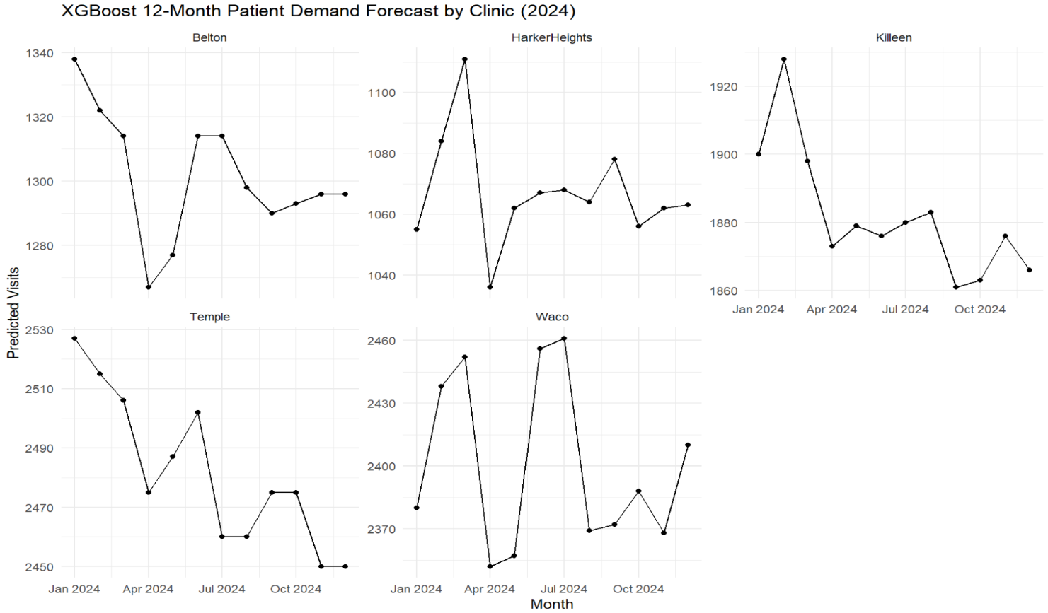
Figure 1. XGBoost 12-Month Patient Demand Forecast by Clinic (2024)

Figure 2. XGBoost 12-Month System-Wide Patient Demand Forecast (2024)
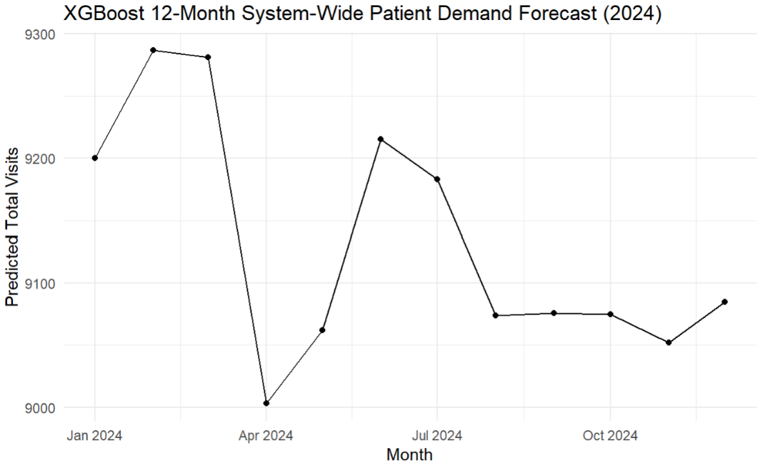

Interpretability, Operational Risk, and Maintainability

The classical models possess a clear advantage in interpretability and maintainability. Trends, seasonal patterns, and COVID-related adjustments can be more readily explained to leadership and operational staff. Moreover, XGBoost, whilst powerful and scalable, functions as a less transparent model and requires relatively greater technical oversight.
From an operational perspective, the adoption of machine learning forecasting would introduce additional maintenance requirements, including feature updates, model retraining, and ongoing monitoring to prevent model performance from deteriorating over time. For a healthcare network making staffing and capacity decisions, transparency and reliability are therefore just as paramount as raw predictive power.

Recommendation

Texas HealthLink should not replace its existing classical forecasting framework with XGBoost at this time. The TSLM and ETS models demonstrated stronger forecast accuracy, higher interpretability, and lower associated operational complexity. These models should remain the primary tools for routine staffing, budgeting, and clinic-level demand planning.

However, machine learning forecasting should continue to be explored as a complementary capability. XGBoost may potentially become more valuable if Texas HealthLink expands to additional clinics, incorporates external predictors (such as population growth or epidemiological indicators), or seeks to model more complex demand patterns that may not necessarily be linear in nature. Under the aforementioned conditions, ML forecasting may then provide additional strategic value, especially for high-volume clinics such as Temple and Waco or for broader system-wide planning initiatives.

